Software Requirements Specification
for
MrDresser
Version 1.0 approved
Prepared by Umair Ahmad & Aqeel Abass
Namal University Mianwali
May 6, 2025
Table of Contents
Revision History II
1. Introduction 1
1.1 Purpose 1
1.2 Document Conventions 1
1.3 Intended Audience and Reading Suggestions 1
1.4 Product Scope 1
1.5 References 1
2. Overall Description 2
2.1 Product Perspective 2
2.2 Product Functions 2
2.3 User Classes and Characteristics 2
2.4 Operating Environment 2
2.5 Design and Implementation Constraints 2
2.6 User Documentation 2
2.7 Assumptions and Dependencies 3
3. System Features 3
3.1 System Feature 1 3
3.2 System Feature 2 4
Vendor Profile and Business Management 4
3.2.1 Description and Priority 4
3.3 System Feature 3 5
Product/Service Search 5
3.3.1 Description and Priority 5
3.4 System Feature 4: 5
Location-Based Services (Optional)] 5
3.4.1 Description and Priority 5
3.5 System Feature 5 6
Admin Dashboard and Management 6
3.5.1 Description and Priority 6
4. External Interface Requirements 7
4.1 User Interfaces 7
4.2 Hardware Interfaces 7
4.3 Software Interfaces 7
4.4 Communications Interfaces 7
5. Other Nonfunctional Requirements 8
5.1 Performance Requirements 8
5.2 Safety Requirements 8
5.3 Security Requirements 8
5.4 Software Quality Attributes 8
5.5 Business Rules 8
6. Other Requirements 9
6.1 Use Case diagram: 10
6.2 Level 0 DFD: 11

Revision History
Name | Date | Reason For Changes | Version

Introduction

Purpose
This SRS defines the requirements for the MrDresser Personalized Fashion Recommender, which profiles men with smart clothing recommendations based on their physical appearance e.g. age, face, weight, skin tone and provides personalized dress suggestions depending on the weather, event, occasion and location. It aims to automate and personalize the process of outfit selection using machine learning and user profiling.

Document Conventions
Bold headings indicate major sections. Plane text highlights important references. Requirement IDs follow the format FR-xx for Functional Requirements and NFR-xx for Non-Functional Requirements.

Intended Audience and Reading Suggestions
- Developers: Use this document to implement features.

- Testers: Base your test cases on the functional requirements.

- Users: Refer to the overview for an understanding of product behavior.

- Project Managers: Track progress and validate system deliverables.

Product Scope
MrDresser will act as a virtual wardrobe consultant. It provides style suggestions based on the user's biometric and contextual data, enhancing the personal shopping experience and increasing user satisfaction. It is particularly targeted toward working professionals, students, and style-conscious individuals.

References
- IEEE 830-1998 – Recommended Practice for Software Requirements Specifications

- OpenWeatherMap API for weather integration

- Python OpenCV for face and color detection

Overall Description

Product Perspective
MrDresser is a standalone web/mobile application. It utilizes external APIs for real-time weather and internal AI algorithms for biometric and contextual analysis.

Product Functions
- Profile creation with user attributes

- Smart dress recommendation engine

- Face and color detection for matching colors

- Event-based suggestion engine e.g., formal vs. casual

- Weather-aware outfit recommendations

- Location and event-based filtering

User Classes and Characteristics
- General Users: Input their information to receive suggestions

- Fashion Consultants: Use advanced settings for clients

- System Admins: Manage database, content updates

Operating Environment
- Platforms: Android, Web Browsers

- OS: Android 10+, Windows 10+, macOS

- Languages: Python (backend), HTML/CSS, JavaScript (frontend)

Design and Implementation Constraints
- Must work with real-time APIs for weather

- Must support image processing libraries like OpenCV, TensorFlow Lite

- Must use secure authentication

User Documentation
- In-app tutorials

- PDF user manual

- Help/FAQ section

- Contact support

Assumptions and Dependencies
- Users have internet access

- Accurate data input from users

- Dependencies: Camera access, external APIs (weather, maps)

System Features

System Feature 1
User Profile and Personalization
3.1.1 Description and Priority
This feature allows users to create a personalized profile by entering or capturing biometric data such as age, gender, weight, face shape, and skin tone. This data is used to tailor clothing recommendations.
Priority: High
Benefit: 9
Penalty: 8
Cost: 4
Risk: 6

3.1.2 Stimulus/Response Sequences
Stimulus 1: User opens the profile page.

Response: System displays a form for entering personal data name, age, weight, etc.

Stimulus 2: User submits profile details.

Response: System stores data and updates recommendation logic.

Stimulus 3: User uploads or captures an image.

Response: System analyzes the image to determine face shape and skin tone.
3.1.3 Functional Requirements
REQ-1: The system shall allow users to enter and update their age, gender, weight, and profession.

REQ-2: The system shall enable users to upload a profile picture for automatic face shape and skin tone detection.

REQ-3: The system shall analyze the uploaded image using a face detection algorithm to extract face shape and color information.

REQ-4: The system shall store the user's profile data securely and associate it with their account.

REQ-5: If an invalid image format is uploaded, the system shall return an error message: “Unsupported image format. Please upload JPG or PNG.”

REQ-6: The system allow the user to view and edit their profile at any time.

REQ-7: The system shall use the profile data to filter and prioritize outfit recommendations accordingly.

System Feature 2

Vendor Profile and Business Management

3.2.1 Description and Priority
Vendors can create and manage their business profiles, including uploading products/services.
Priority: High
Benefit: 9
Penalty: 8
Cost: 4
Risk: 6
3.2.2 Stimulus/Response Sequences
Stimulus 1: Vendor opens profile management page.
Response: System displays form for business name, category, contact info, and location.
Stimulus 2: Vendor submits business profile.
Response: System stores data and displays vendor dashboard.

Stimulus 3: Vendor updates profile or uploads products.
Response: System validates and reflects changes in real-time.

3.2.3 Functional Requirements
REQ-6: The system shall allow vendors to create and update business profiles.
REQ-7: The system shall allow vendors to upload product listings with name, description, price, and images.
REQ-8: The system shall validate input fields and image formats.
REQ-9: The system shall store vendor data securely in the database.

System Feature 3

Product/Service Search

3.3.1 Description and Priority
This feature enables users to search for nearby shops and filter services/products based on input.
Priority: High
Benefit: 10
Penalty: 9
Cost: 5
Risk: 4
3.3.2 Stimulus/Response Sequences
Stimulus 1: User enters keyword in search bar.
Response: System displays relevant vendors/products.
Stimulus 2: User filters results by category/distance.
Response: System narrows down and re-renders results.
Stimulus 3: User clicks on a vendor.
Response: System displays vendor profile and available items.
3.3.3 Functional Requirements
REQ-10: The system shall allow users to perform keyword-based searches.
REQ-11: The system shall support filtering by product category and vendor type.
REQ-12: The system shall sort results by proximity (if location access is granted).
REQ-13: The system shall handle empty result sets gracefully with appropriate messages.

System Feature 4:

Location-Based Services (Optional)]

3.4.1 Description and Priority
Enhances usability with map-based search and directions.
Priority: Medium
Benefit: 8
Penalty: 6
Cost: 6
Risk: 7
3.4.2 Stimulus/Response Sequences
Stimulus 1: User allows location access.
Response: System retrieves user coordinates.
Stimulus 2: User views map.
Response: System marks nearby vendors on map interface.
Stimulus 3: User requests directions.
Response: System displays route using Maps API.
3.4.3 Functional Requirements
REQ-14: The system shall optionally request and retrieve user location.
REQ-15: The system shall display vendors on a map interface.
REQ-16: The system shall use Google Maps API to generate route directions.
REQ-17: The system shall not store user location without consent.

System Feature 5

Admin Dashboard and Management

3.5.1 Description and Priority
Admin oversees user/vendor activity and approves listings.
Priority: High
Benefit: 9
Penalty: 7
Cost: 5
Risk: 4
3.5.2 Stimulus/Response Sequences
Stimulus 1: Admin logs in.
Response: System displays dashboard with pending approvals.
Stimulus 2: Admin reviews a vendor/shop.
Response: System updates approval status and reflects listing visibility.
Stimulus 3: Admin removes a reportable entry.
Response: System deletes or flags content.
3.5.3 Functional Requirements
REQ-18: The system shall provide an admin dashboard for user/vendor monitoring.
REQ-19: The system shall allow admins to approve or reject vendor listings.
REQ-20: The system shall support the removal of inappropriate or invalid content.
REQ-21: The system shall log admin activities for auditing.

External Interface Requirements

User Interfaces
<Describe the logical characteristics of each interface between the software product and the users. This may include sample screen images, any GUI standards or product family style guides that are to be followed, screen layout constraints, standard buttons and functions (e.g., help) that will appear on every screen, keyboard shortcuts, error message display standards, and so on. Define the software components for which a user interface is needed. Details of the user interface design should be documented in a separate user interface specification.>

Hardware Interfaces
In Progress

Software Interfaces
In Progress

Communications Interfaces
The MrDresser system requires several communication functions to support real-time data interaction and service delivery:
- Web Browser Compatibility: The application will operate through modern web browsers (Chrome, Firefox, Edge) with responsive design support.
- API Communications: The system interacts with external services using standard HTTP/HTTPS protocols:
  - Weather API: Provides real-time weather data to personalize dress recommendations.
  - Maps API: Supplies map-based data for vendor location and direction services.
- Authentication Protocols: All user roles (General User, Vendor, Consultant, Admin) will authenticate via secure HTTP(S) using token-based sessions or OAuth.
- Message Formatting: Data exchange between client and server will be in JSON format to ensure lightweight and structured communication.
- Security & Encryption:
  - All communication will be encrypted using SSL/TLS protocols.
  - Sensitive user data (e.g., profile info) will be transmitted and stored securely.
- Data Transfer: System is optimized for lightweight communication ensuring minimal latency; typical transfer rates depend on the client’s internet speed.
- Synchronization: Real-time syncing ensures recommendation results and product updates reflect instantly using AJAX/RESTful APIs.

Other Nonfunctional Requirements

Performance Requirements
• NFR-01: Initial page load < 3 seconds
• NFR-02: Search results must return within 2 seconds

Safety Requirements
• Data validation on all inputs to prevent errors and misuse
• Backup strategy for MongoDB database

Security Requirements
• NFR-03: All passwords stored using hashing (e.g., bcrypt)
• NFR-04: Use HTTPS for all communications
• NFR-05: Admin access protected with strong authentication

Software Quality Attributes
• Maintainable: Modular code and reusable components
• Scalable: Support for increased number of users/shops
• Usable: Intuitive UI with minimal learning curve

Business Rules
• Only verified vendors can publish listings
• Admin approval is required before shop is visible
• Shops must update profiles periodically to remain listed

Other Requirements
• Optional multilingual support
• Compliance with local e-commerce regulations (if applicable)
Appendix A: Glossary
• Vendor: A shop owner or service provider using NearBuy
• User: A general user searching for products/services
• MongoDB: NoSQL database used for storing application data
• React.js: JavaScript frontend framework
• API: Application Programming Interface
Appendix B: Analysis Models

Use Case diagram:
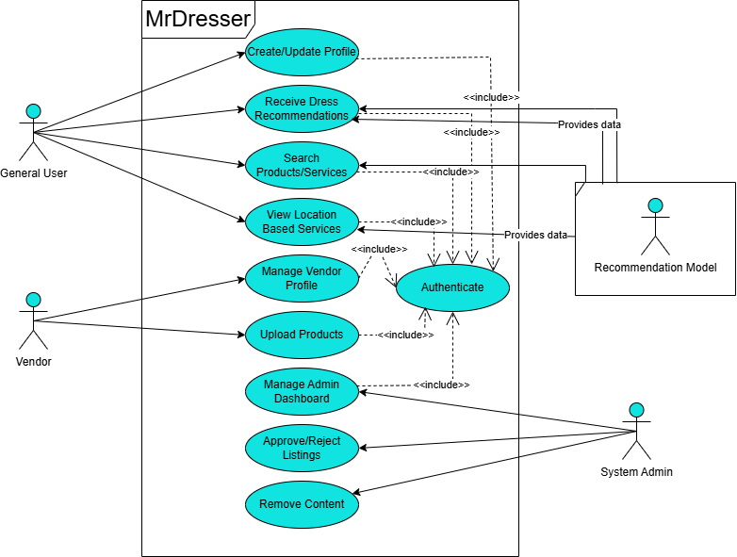
Figure 1

Level 0 DFD:

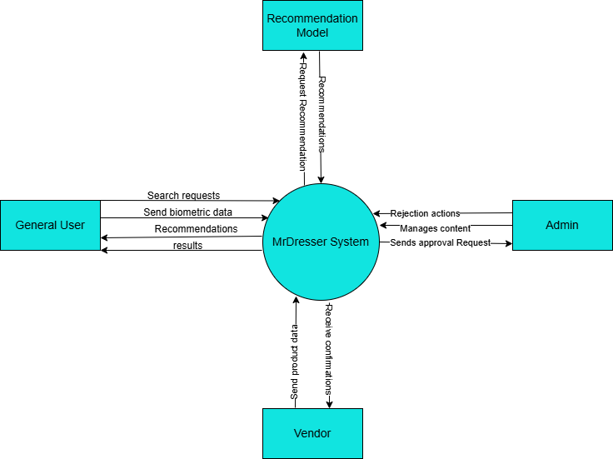

Figure 2
Appendix C: To Be Determined List
• TBD-1: Final decision on using Google Maps API
• TBD-2: Admin dashboard design layout

